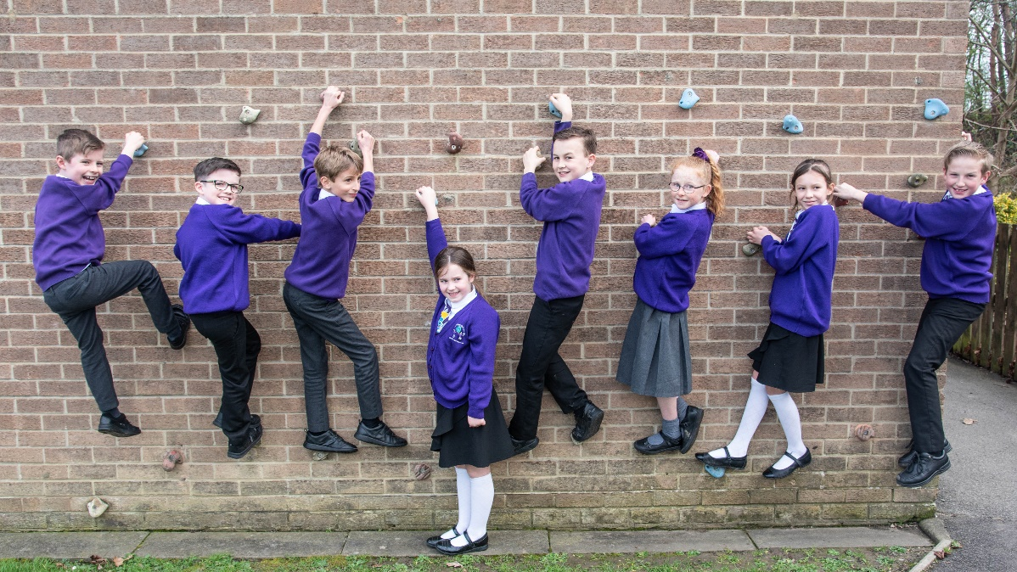
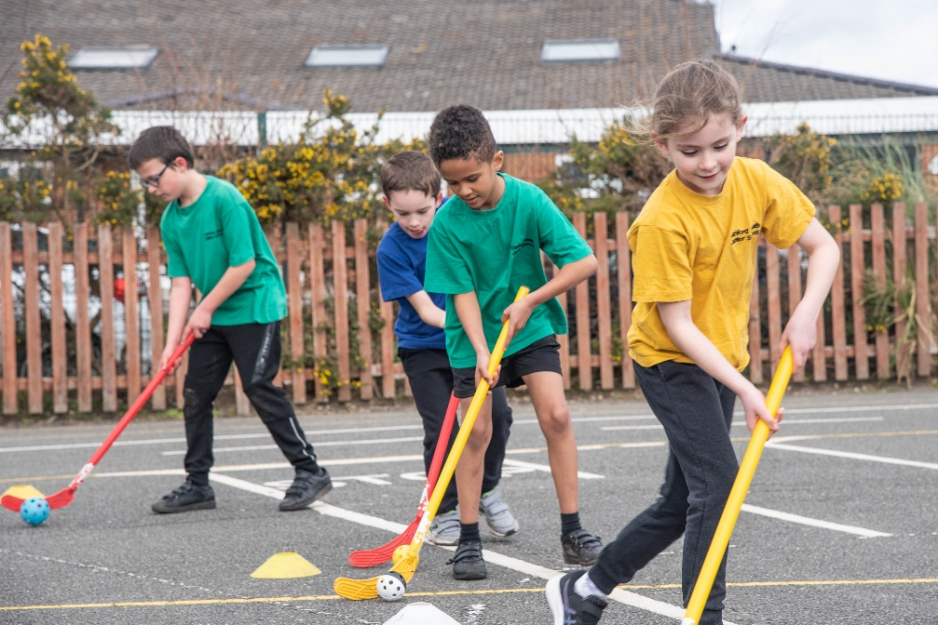
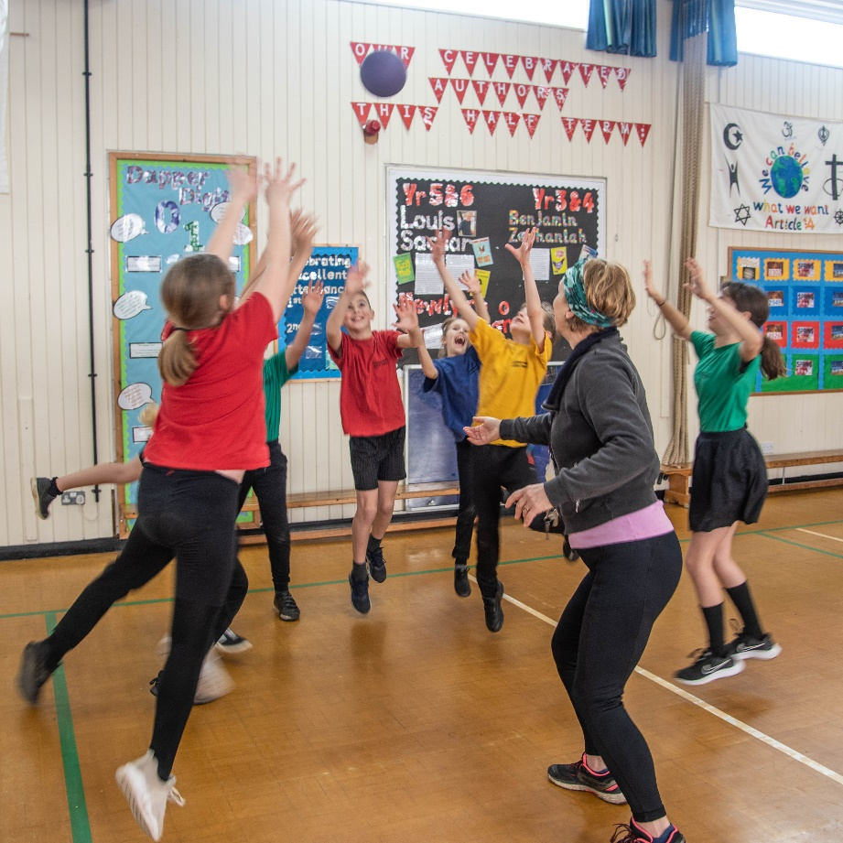
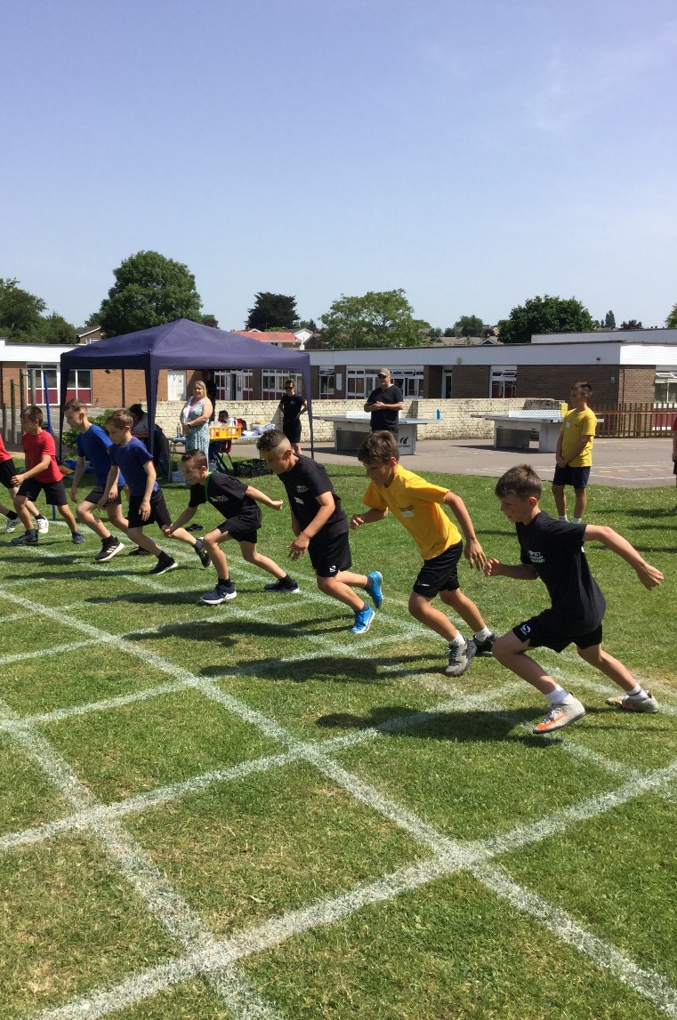
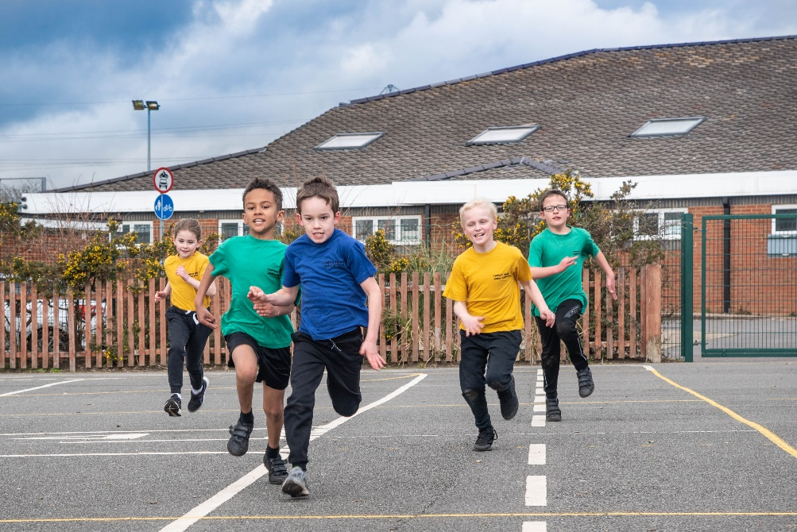
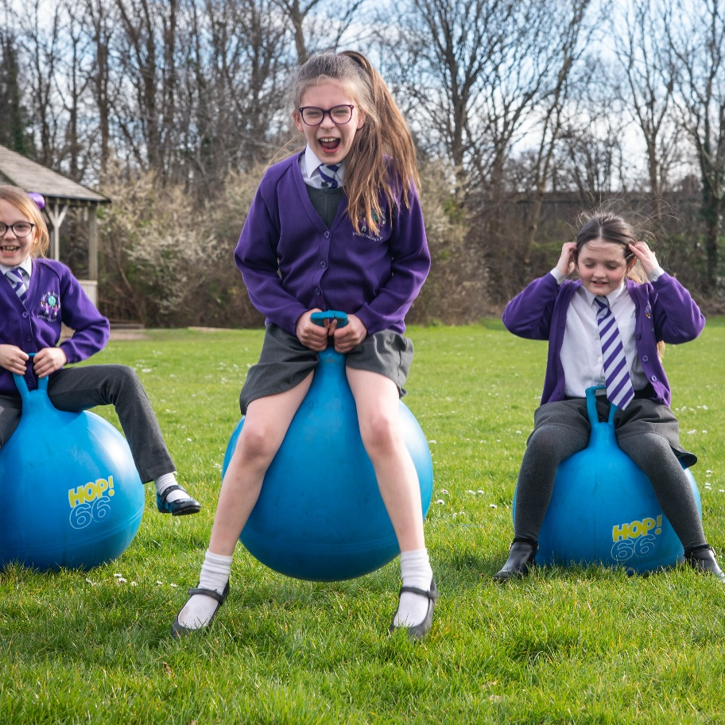
CANFORD HEATH JUNIOR SCHOOL

PE AND SPORTS PREMIUM IMPACT REPORT FOR THE 2023-2024 ACADEMIC YEAR

Details with regard to funding

Total amount carried over from 2022/23 | £2211
How much (if any) do you intend to carry over from this total fund into 2021/22? | £2211
Total amount allocated for 2022/23 | £20740
Total amount of funding for 2023/24. To be spent and reported on by 31st July 2024. | £22951(£20740 + £2211)
Total spend 2023/24 | £23160.13
Swimming Data

Meeting national curriculum requirements for swimming and water safety.  Due to exceptional circumstances priority should be given to ensuring that pupils can perform safe self-rescue even if they do not fully meet the first two requirements of the NC programme of study | Covid-19 has Impacted our usual swimming catch up programme) where our current year 6 would have had the opportunity to do additional swimming sessions in their y4 & y5
What percentage of your current Year 6 cohort swim competently, confidently and proficiently over a distance of at least 25 metres?  N.B. Even though your pupils may swim in another year please report on their attainment on leaving primary school at the end of the summer term 2024. | 87%
What percentage of your current Year 6 cohort use a range of strokes effectively [for example, front crawl, backstroke and breaststroke]? | 87%
What percentage of your current Year 6 cohort perform safe self-rescue in different water-based situations? | 87%
Schools can choose to use the Primary PE and sport premium to provide additional provision for swimming but this must be for activity over and above the national curriculum requirements. Have you used it in this way? | Yes: additional swimming on Friday lunchtimes for year 4, 5 and 6 and Tuesday afternoons in Autumn term

Action Plan and Budget Tracking

Academic Year: 2023/24  c/o to 2024 £2211 | Total fund allocated: £22951 | Date Updated: July 2024
Key indicator 1: The profile of PESSPA being raised across the school as a tool for whole school improvement |  |  |  | Percentage of total allocation:
 |  |  |  | 9%
Intent | Implementation |  | Impact
Your school focus should be clear what you want the pupils to know and be able to do and about  what they need to learn and to  consolidate through practice: | Make sure your actions to achieve are linked to your intentions: | Funding allocated:  £2116.36 | Evidence of impact: what do pupils now know and what can they now do? What has changed?: | Sustainability and suggested next steps:
.Smoother transition between year 2 to year 3 for mental well-being  .Use sport to enhance and build self-esteem of SEND pupils  .Use PESSPA to support mental well-being of identified children  .Increase activity in lesson other than PE by having more practical learning  activities. (tracking wellbeing)  .Use physical activity to promote well-being | Sports activities afternoon organised with y2 and y5 & appropriate resources  Raise participation levels of SEND pupils by participating in at least 3 SEND specific level 2 activities/festivals of sport  Resources to enable SEND pupils to attend school sport and physical activity clubs  Affiliate to Well-Schools (YST) and My Personal Best (YST)  Create a whole school ‘Teach Active’ policy - Identify, implement and develop ‘An outdoor learning programme’  including outdoor mindfulness club –  Sports Leaders publish online a weekly for pupils, staff and families to join in with.  Survey pupils attending activities about enjoyment and self-confidence and identify activities that they feel would enhance their self-esteem & or improve their mental well-being  Ensure sufficient resources | £796.65  £178  Speed guns for maths lessons  £235.98  £905.76 | 100% pupils coming to CHJS from CHIS attend transition afternoon  SEND pupils give positive responses to enjoyment & self-confidence in Active Lives Survey  Teachers systematically include active starters/activities in lesson planning  100% pupils engage in 5 minutes of physical activity a minimum of twice a week in lessons other than PE  Most pupils state enjoyment when participating in these activities  Offering a diverse range of sports and extra-curricular physical activity opportunities to enrich pupils’ experience of school now means that 46% feel strongly that they feel confident when exercising and playing sports - increase of 5% (ALS 2024)  GOLD Healthy Schools award 2023-24 achieved again | Continue next year  Continue to participate in Active Lives Survey in Spring 2025  Teach Active policy to be continued to be developed in 2024-25  ‘Outdoor Club’ to commence September 2025  Continue to use Well Schools research to improve education outcomes
Key indicator 2: The engagement of all pupils in regular physical activity – Chief Medical Officers guidelines recommend that primary school pupils undertake at least 30 minutes of physical activity a day in school |  |  |  | Percentage of total allocation:
 |  |  |  | 11%
Intent | Implementation |  | Impact
Your school focus should be clear what you want the pupils to know and be able to do and about  what they need to learn and to  consolidate through practice: | Make sure your actions to achieve are linked to your intentions: | Funding allocated:  £2474.20 | Evidence of impact: what do pupils now know and what can they now do? What has changed?: | Sustainability and suggested next steps:
Improve attitudes to Physical activity and Sport:  Improve confidence when participating from 41% (ALS 2023) to 50+%  Increase understanding of why physical activity is important and ‘good for you’ from 72% (ALS 2023) to 80+%  .Move pupils who are fairly active to active across the week  .Move pupils who are less active to fairly or better  .Increase active travel to and from school  Explicit promotion of our PESSPA raison d’etre: ‘There’s something for everyone’  .Create a pupil Sports Crew to raise the profile of School Sport & Activity, through lunchtime ‘sports activities’  .Promote wrap around provision by creating community ‘free’ activities  Ensure that booster swimming is not impacted by school visits and subsequent loss of school minibus transportation | Participate in Active Lives Survey 23-24  Use whole school assemblies, especially Friday presentation assembly, to raise the profile of PESSPA.  Participate in WOW and Sustrans activities: pupil voice inspirational visitor assembly and whole day workshops  Pupil voice on lunchtime activities and purchase varied physical activity equipment  Survey of active travel  Displays/pupil voice inform creation of staff led lunchtime clubs  Sports crew lead out of school fitness weekly video - rewards  Reward continued participation in WOW and sustainable travel  Release staff to organise Sports crew  PE team to meet regularly and set up community activities  Hire minibus to enable booster swimming to continue to maintain engagement of targeted less active pupils  Activity trackers (MOKI) additional resources | Terry Price £310  £878.64  £730.03  £85.40  £395.58  £74.55 | 10 Sports Ambassadors have been trained to lead activities and regularly support in PE lessons in lower year groups  Sports leaders activities promoted in whole school celebration assemblies raising profile to all stakeholders  46% feel strongly that they feel confident when exercising and playing sports - increase of 5% (ALS 2024)  75% understand why physical activity is important and ‘good for you’ (ALS 2024)  51% of boys and 50% girls do an average of 30+ minutes a day of moderate to vigorous activity in school  Consistently in the top 3 schools in BCP for Active travel (WOW 2023-24)  Majority of children wear their WOW reward travel badges  WOW/Sustainable travel part of whole school celebration assemblies raising profile to all stakeholders  WOW tracker shows a consistent downward trend across the year in NON-active travel from September 2023 (avg.20%) to July 2024 (11% avg) well below the National average of 42%  Weekly Celebration assembly sharing of what pupils do outside school – majority is sport & physical activity | Continue to use Pupil voice to increase confidence in participating  Increase engagement in Sports Leaders out of school activities  Continue to use Well Schools to develop strategies in whole school approaches to Physical Health & literacy  Continue to use WOW and access to SUSTRANS to promote and track active travel – ensure early sign up to access free resources  Slight drop in physical activity (5%) rates in school consistent with inability to participate in and track Daily Mile as a breakfast club due to on site parking of Winchelsea minibuses at 8.15am: review & re-organise.

Key indicator 3: Increased confidence, knowledge and skills of all staff in teaching PE and sport |  |  |  | Percentage of total allocation:
 |  |  |  | 33%
Intent | Implementation |  | Impact
Your school focus should be clear  what you want the pupils to know  and be able to do and about  what they need to learn and to  consolidate through practice: | Make sure your actions to  achieve are linked to your  intentions: | Funding  allocated:  £7540.48 | Evidence of impact: what do  pupils now know and what  can they now do? What has  changed?: | Sustainability and suggested  next steps:
. Maximise CPD opportunities for staff by inviting specialists to lead curriculum sessions for pupils to continue programme of upskilling teachers so  pupils have high quality PE lessons, delivered by confident and knowledgeable staff using high quality planning.  . Pupils are fully engaged within PE lessons and are physically active for most of it.  . Use selected online lessons as part of indoor modules to resource quality lessons for non-specialist teachers and to aid teacher confidence in the teaching of identified sports/activities.  .Teaching of swimming cpd – upskill PE team | Use self-assessment tool to prioritise all years CPD:  handball  orienteering  target games  CPD – release or online  Purchase equipment to engage pupils  in dynamic PE lessons  Increase learning time by having easily accessible equipment  Team teaching – release of PE lead & PE team to plan & teach alongside members of staff  .Release PE specialist to lead swimming sessions across the school and upskill accompanying teachers/HLTAs to increase their confidence in leading small groups of swimmers focus on non-swimmers and building confidence out of depth  Access to CPD through membership to AfPE | £200 handball whole school CPD  £1894.90  £157.25  Online lesson modules  £5000  £288.33 | Handball CPD - all teachers & HLTAs  enabled to deliver quality PE lessons  Handball incorporated into all years PE curriculum and key skills tracked in MTPs  Moveable storage enables staff to set up lessons quicker and increasing learning/activity time.  Children more active in PE for longer  2 adults accompanying swimming ready to complete Swim England Assistant teacher of Primary Swimming CPD | Internal cover if funds unavailable for supply to continue to allow for CPD  After-school CPD led by PE leaders and PE team  Subject leader will continue to be released to ensure that swimming delivery is confidently taught by accompanying adults  ECTs to receive enhanced CPD support  Continue to use AfPE online CPD  PE lead to complete lesson observations in lessons where CPD has been received  Continue to release PE lead & PE team to plan & teach alongside members of staff
Key indicator 4: Broader experience of a range of sports and activities offered to all pupils |  |  |  | Percentage of total allocation:
 |  |  |  | 37%
Intent | Implementation |  | Impact
Your school focus should be clear  what you want the pupils to know  and be able to do and about  what they need to learn and to  consolidate through practice: | Make sure your actions to  achieve are linked to your  intentions: | Funding  allocated:  £8575.65 | Evidence of impact: what do  pupils now know and what  can they now do? What has  changed?: | Sustainability and suggested  next steps:
. Maintain levels of sport & activities being offered as for 2022-23 or better within the school environment  . Pupil voice for extra-curricular activities  . Pupil self-confidence and wellbeing improved through Outdoor and Adventurous activities.  . Additional swimming in y4, y5 and 6  Continue to find ways to increase number of non-pay clubs during and after school  Continue to increase links with external clubs for additional exit routes  Ensure that pupils not attending residential have an OAA experience  Increase % of pupils attending residential back to pre-covid levels | Survey children for choice of extra-curricular activity  Target PP children to allow access to clubs by providing more lunchtime sports clubs  Maintain variety of extra-curricular activities on offer – identified by pupil voice lead by staff and external provision  Increase clubs that school has exit route to in the local community by inviting club leaders to provide taster sessions in curriculum time and developing school time clubs  Maintain access to Outdoor & Adventurous activity opportunities through involvement in Year 6 residential and Year 5 climbing experience  Hire of swimming pool and extra swim instructor for additional swimming  on Fridays for higher quality swim lessons due to lowering teacher: pupil ratio meaning promoting faster catch up and more targeted pupils accessing it  Autumn term = 3 hours per week  Spring + Summer terms = 1 hour per week  Physical literacy  Ensure sufficient resources to publicise clubs and opportunities and enable access. | £763 (rugby)  £5400  £1125 (pool)  £1166.25  (extra instructor)  £121.40 | Soft Archery & clubs created through pupil voice  Lunchtime sports club enable more PP children to attend free clubs  Quidditc, Rounders & Girls football  Termly promotion of after school clubs has led to fully subscribed clubs  Uptake to handball from lower school pupils increased after in school taster sessions  Uptake to girls’ football increased and maintained through half-term input from AFC Bournemouth community coaches  98% y5 attended climbing experience  88% of all year 6 participated in Residential  (% who didn’t participate supported in alternative activities back at school)  Covid impact on pupils’ swimming significantly decreased: less children in the upper juniors will require additional swimming lessons:  4, 5 & 6 pupils targeted 51% attained KS2 swimming expectations through additional swimming and a further 24% attained KS2 swimming stroke expectations  Bikeability courses – pupil voice – 24 year 5 & 6 pupils attained level 1 and 2  Handball, Karate, Tag Rugby and  Dodgeball maintained | New sports crew each year trained by PE lead  Create Club links to external archery club  Use RIPPA rugby to create a generic lunchtime sports club to further target specific children  Continue to target girls as majority of girls’ data (ALS 2024) shows they are less active in school (50%) than out of school (62%)  Return of swim fit club on Fridays rather than booster swimming as more children now require swimming stamina than learning how to swim

Key indicator 5: Increased participation in competitive sport |  |  |  | Percentage of total allocation:
 |  |  |  | 11%
Intent | Implementation |  | Impact
Your school focus should be clear  what you want the pupils to know  and be able to do and about  what they need to learn and to  consolidate through practice: | Make sure your actions to  achieve are linked to your  intentions: | Funding  allocated:  £2453.44 | Evidence of impact: what do  pupils now know and what  can they now do? What has  changed?: | Sustainability and suggested  next steps:
.Maintain the levels & breadth of activities for participation of pupils across the whole school at level 1 and level 2 sport  .Maintain level 2 competition by organising whole year group activities  with other TEACH trust junior school:  Y3 cricket; y4 football; y5 virtual Quadkids & y6 virtual Quadkids meaning 100% of ALL children in the school will participate in level 2 competition  .Maintain participation levels of SEND pupils by participating in at least 3 SEND specific level 2 activities/festivals of sport  .Maintain GOLD accreditation for School Games | PE lead and PE team to identify activities from PEDSSA and SGO calendars of events and put together a programme of activities to attend  (attend termly PEDSSA meetings)  Ensure that school minibuses and cover are booked to enable participation in events that are in school time. Organise alternatives if school minibuses are unavailable due to other school events/activities/visits to ensure high level of attendance  Motivate children through PE lessons and taster sessions and rewards for representing school  Organise sports clubs and fixtures that enable, enrich & extend  Use Celebration Assemblies to raise profile of representative sports  Rewards for school held level 1 and level 2 competitions  Purchase team kit for events such as athletics, handball & football and team outer wear to raise school identity at fixtures and sports events  Liaise with Winchelsea CHJS unit to organise SEN level 2 activities with them  Attend specific School Games activities organised by SGOs | £172.05 PEDSSA membership & entry fees & fixtures  £1343.67  £259.67  £678.05 | Cross country teams  Football teams – all year groups and girls only in y4,5,6  SEND Panathlon team  SEND 10 Pin bowling team  SEND football  SEND multi-sports festival  Indoor Athletics team  Trigolf teams  Athletics (Quadkids and track & field) teams  Handball teams  All y3 participated in level 2 cricket activities  All y4 participated in level 2 football activities  All y5 participated in level 2 Quadkids athletics festival  All y6 participated in level 2 Quadkids  4 SEND specific events attended  82% of all SEND pupils participated in 1 or more SEND specific level 2 events  21% of all SEND pupils participated in 2 or more SEND specific level 2 events  100% of all SEND pupils participated in 1 or more level 2 events  87% of all SEND pupils participated in 2 or more level 2 events  100% of all PP pupils participated in 1 or more level 2 events  56% of PP pupils participated in 2 or more level 2 activities  School Games County Finals achieved in 2 events  School Games GOLD accreditation achieved  100% pupils experienced level 2 competition  100% pupils experienced level 1 competition | Maintain current level of level 1 and level 2 sport  Continue to incorporate level 1 School Games Festivals within the curriculum  Continue to find ways to maximize level 1 and level 2 competition by using end of unit competitions within school and participating against local school that is a walkable distance away i.e. no transportation costs  Continue to use PESSPA tracker of activities that each child has participated in in order to target children  Target BAME pupils

Total: £23160.13 (£209.13) overspend covered by additional school funds)

Signed off by
Head Teacher: | 
Date: | 18/7/24
Subject Leader: | Debbie Laishley
Date: | 17/07/24
CEO:
Date:

