CANFORD HEATH JUNIOR SCHOOL

GUITAR TEACHER

Meryl Hamilton

merylina@hotmail.co.uk

£52 for 10 shared lessons
£80 for 10 1-1 lessons
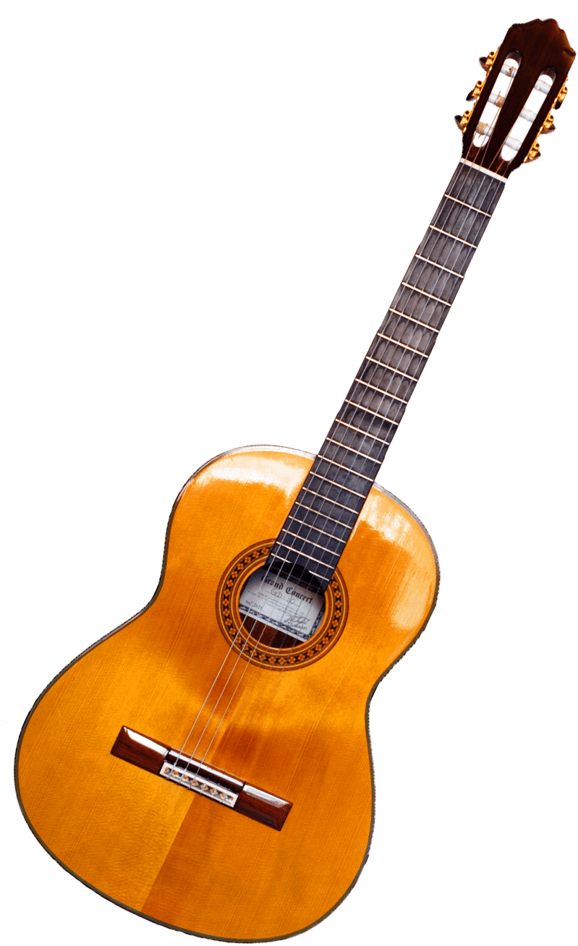
This Photo by Unknown Author is licensed under CC BY-NC

