TEACH Trust Special Education Needs and Disabilities (SEND) Information Report 2025-2026








The TEACH Trust SEND Information Report contains annually updated information about how children with SEND are included. We comply with the statutory requirement to publish SEND information as specified in paragraphs 6.79 to 6.83 of the SEND Code of Practice: 0 to 25 years (2015). This information is kept under review and updated annually in liaison with Trustees and staff. The SEND Information Report must include guidance about the Local Authority’s local offer, and this information is detailed below.

What is the Local Offer?
Every Local Authority must have a local offer that is available on the internet and must make sure that people without access to the internet can also see it. The Local Authority must tell children, young people and their families how they can find out more about the Local Offer.

the_local_offer_for_send_support (bcpcouncil.gov.uk)

Local Authorities are required to publish information on services and provision across education, health and social care for children and young people aged 0-25 with Special Educational Needs and Disabilities (SEND). The purpose of a local offer is to enable parents and carers to see more clearly what services are available for children with SEND in their area and how to access them. The information that follows in this report forms the TEACH Trust’s contribution to the local offer.



The Bournemouth, Christchurch and Poole SEND Local Offer can be found via this link:
The Bournemouth, Christchurch and Poole SEND Local Offer - BCP Council

SEND Services BCP Council: SENDbso@bcpcouncil.gov.uk

What is the TEACH Trust vision for children with SEND?

All TEACH staff and Trustees have high aspirations for all the children identified as having SEND in our schools no matter what their needs or barriers. We strive to ensure that all the children achieve their best and become confident individuals living fulfilling lives.

We are a Rights Respecting Trust and work with due regard for the principles of the United Nations Convention on the Rights of the Child in particular articles 23, 28 and 29. These articles describe the rights of all children to have an education that develops their “personality, talents, mental and physical abilities to their fullest potential” and the rights of children with special needs to have conditions which ensure “dignity, promote self-reliance and facilitate the child’s active participation in the community”.

Our ambition is to ensure all children are part of a fully inclusive environment and we actively strive to advance the equality opportunities for every single child. Our SEND policy aims to set out how our TEACH Trust schools will support and make provision for children with special educational needs and disabilities (SEND), and explain the roles and responsibilities of everyone involved in providing for children with SEND. The Trust policy for SEND is available on each school’s website. It is the intention of the TEACH Trust schools to work collaboratively with families, in order to coordinate the working approach pursuant to the SEND Code of Practice: 0 to 25 years (2015). Fundamental to the SEND Code of Practice is the belief that children and their families’ involvement is central to securing the best outcomes for pupils with special educational needs and disabilities.

We pride ourselves on being an inclusive Trust with a range of expertise in supporting a wide variety of needs. We are committed to the professional development of staff and they are supported well to meet pupils’ needs, either from direct training in school or external specialist advice. We aim to address children’s needs and support their development in the most appropriate way possible and celebrate effort as much as achievement.

What are Special Educational Needs and Disabilities (SEND)?
In line with the BCP Council’s graduated approach, the TEACH Trust implements additional and/or different provision for children with a range of special educational needs and disabilities. The SEND Code of Practice: 0 to 25 years (2015) identifies SEND under four broad areas of need (sections 6.28 to 6.35):

- Communication and Interaction (C&I) – Autistic spectrum condition, Asperger’s syndrome, selective mutism, speech and language difficulties
- Cognition and Learning (C&L) - Specific learning difficulties (such as dyspraxia, dyslexia and dyscalculia), moderate learning difficulties and profound and multiple learning difficulties
- Social, Emotional and Mental Health difficulties (SEMH) - Attention deficit hyperactivity disorder, emotional needs, social interaction difficulties, anxiety, attachment difficulties
- Sensory and/or Physical needs (PD) - Hearing impairment, visual impairment, sensory processing difficulties, epilepsy, physical impairment or disability

Link to the SEND Code of Practice: 0 to 25 years (2015): https://www.gov.uk/government/publications/send-code-of-practice-0-to-25

Who are the best people to talk to in school about my child’s Special Educational Needs and/or Disabilities (SEND)?

The Class Teachers | The class teacher has full accountability and responsibility for all the children in their class, including children with SEND. Should you wish to speak to someone about your child’s SEND, then the class teacher will be the first point of contact.  The class teacher is responsible for:  - the progress and development of every child in their class  - ensuring all children have access to good or outstanding teaching and that the curriculum is adapted to meet every child’s needs  - monitoring the progress of every child and identifying barriers to learning through assessment for learning strategies  - planning and delivering any additional or different support (ways in) a child with SEND may need to access the curriculum and to overcome barriers to learning (this support could look like targeted work, specific access arrangements, targeted intervention, a differentiated task design, specific resources, etc.)  - creating individual education plans (IEPs) and setting specific and personalised targets.  - sharing and reviewing IEP targets with parents/carers at parent consultation evenings and IEP meetings  - providing specific feedback to individual children on what they have achieved and how they can progress through regular marking of work, prompt verbal feedback and conferencing  - knowing the needs of the children and being well-trained to meet the needs of all children in their care.
The Inclusion Leaders  Mrs Chandler  - Ad Astra Infant School  Mrs Hardwicke  – Canford Heath Infant School  Mr Proffitt  - Haymoor Junior School  Mrs Turner  – Canford Heath Junior School | Our Inclusion Leaders are either SENDCo accredited or currently undertaking the SENDCo qualification, have experience of working in a range of mainstream schools and in supporting pupils with SEND.  The Inclusion Leader is responsible for:  - having day-to-day responsibility for the operation of the SEND policy and the co-ordination of specific provision made to support individual children with SEND, including those who have EHC plans, to ensure, where possible, that children receive a consistent, high-quality response to meeting their needs in school  - working with staff and families in identifying needs and providing support  - updating the school’s SEND register (a flexible document outlining the SEND needs of pupils in each school) and ensuring school staff are aware of the specific needs of individual pupils  - ensuring that EHC plans are implemented where appropriate, and reviewed as part of the Annual Review process  - leading staff training and providing professional guidance through SEND conferencing to further staff expertise and so develop and improve practice  - supporting staff with the provision for children with SEND  - briefing the leadership team and Trust board on issues relating to SEND  - liaising regularly with the SEND Trustee, Head of Inclusion and SEND, class teachers, support staff and the Pastoral Care team regarding SEND provision  - monitoring assessment, progress, targets and Individual Education Plans (IEPs) in line with the graduated approach  - line managing, co-ordinating and supporting the team of SEND teaching assistants  - being the point of contact for external agencies and liaising with relevant support services  - ensuring external professional agency advice is implemented  - advising school staff of recommended strategies and resources to support individual pupils with SEND  - attending multi agency meetings and co-ordinating work with outreach services  - attending transition meetings and liaising with feeder and destination schools  - ensuring SEND and Pupil Premium registers, and school records relating to SEND, are reviewed and kept up to date  - ensuring all members of staff working with children in school are aware of children’s individual needs and/or conditions and what specific adjustments could be made to enable them to be fully included and make progress  - ensuring that parents/carers are:  - involved in supporting their child’s learning  - kept informed about the support their child is receiving  - involved in reviewing how their child is progressing  - part of the process of planning ahead for their child
The Head of Inclusion and SEND  Miss Brown – TEACH Trust | The Head of Inclusion and SEND will work with the CEO, SEND Trustee, Headteachers and Inclusion Leaders to determine the strategic development of the SEND policy and provision in the TEACH Trust schools.  The Head of Inclusion and SEND is responsible for:  - leading the Trust in embracing a positive culture of inclusion  - undertaking a continuous process of monitoring and assessment to inform the educational provision across the Trust  - supporting the Head of Curriculum and Standards and Inclusion Leaders in securing effective intervention, ensuring it is regularly reviewed  - reporting to Trustees  - quality assuring Individual Education Plans and SEND provision across the Trust  - securing suitable resourcing and funding to meet the needs of children with additional needs within the Trust  - overseeing the two SLCN Resource Bases at Canford Heath Infant and Junior School including  - undertaking a continuous process of monitoring and assessment to inform the educational provision in the SLCN Resource Bases  - supporting the SLCN Base Managers in implementing a purposeful, broad and balanced curriculum, ensuring it is regularly reviewed
SEND Trustee | The SEND Trustee is a critical friend who is responsible for:  - helping to raise awareness of SEND issues at SEND board meetings and Trust board meetings  - monitoring the quality and effectiveness of SEND provision within the school and update the Trust board on this  - working with the Head of Inclusion and SEND, Head of Curriculum and Standards, Headteachers and Inclusion Leaders to determine the strategic development of the SEND policy and provision in the school
What does inclusion mean?
Inclusion is the concept that everyone should be able to access all appropriate areas of learning, take part in appropriate activities and enjoy school experiences, without discrimination. We are committed to providing a caring, friendly and safe environment for all of our pupils so they can learn in a relaxed and secure atmosphere. As a Rights Respecting Trust, all pupils have a right to feel safe and bullying will not be tolerated as part of our Trust. All allegations of bullying will be investigated and addressed appropriately, in line with our Anti-Bullying policy.


Teaching staff have the responsibility to provide high quality and inclusive teaching. With support, they will provide a carefully differentiated curriculum. This means that work within class is planned and pitched at an appropriate level, so that all children are able to access the key learning learning through ‘Ways In’ according to their needs or barriers. Wherever possible, children should be included in all aspects of the curriculum and wider life of the school; adaptations and reasonable adjustments can be considered to enable this to happen, in line with the SEND Code of Practice: 0 to 25 years (2015). Further information about accessibility within the TEACH Trust schools can be found in the school’s accessibility plans on each school’s website or via the school office.

At TEACH Trust, we believe that each child in our school is unique and will require differentiated systems, some needing more support than others. We are aware that being fair does not mean giving everyone the same thing (equality) but giving everyone what they need (equity) with appropriate support, in line with our TEACH Trust Relationship and Behaviour Policy.

What are the different types of support available within the TEACH Trust for pupils with SEND?
All children and young people with SEND will have an identified primary area of need and many will have secondary or additional needs across a range of other areas. Every child is unique and it is important that it is the individual child and their range of needs which are addressed when deciding how best to support them.
The TEACH Trust staff use a graduated response provision map in order to identify need and provide targeted support. Each of the 4 areas of need: ‘Communication and Interaction’, ‘Cognition and Learning’; ‘Social, Emotional and Mental Health’, and ‘Sensory and Physical’ have been broken down into 3 phases of support. These are: ‘Quality First Teaching’, ‘Universal School SEND Support’ and ‘Statutory’ (EHCP) Level of support’.
Quality First Teaching: (Universal)
Quality First Teaching and the use of personalised, differentiated approaches form the universal offer for all children and young people in educational settings. This will include the robust use of the ‘assess-plan-do-review’ cycle, rigorous teacher oversight, and close liaison between the setting and family.

SEND Support: (Universal Plus)
Where Quality First Teaching approaches have not been sufficient to meet the child/young person’s needs and they now require more focused, targeted, additional support, they will be identified as having SEND. The school will implement an Individual Education Plan (IEP) for your child, which will be reviewed at least termly. In some instances, more specialist advice is sought, and the advice implemented and reviewed. Quality First Teaching, including evidenced, robust use of the ‘assess-plan-do-review’ cycle, rigorous teacher oversight, and close liaison between the setting and family will continue.

Statutory: (EHCP)
Only a small percentage of children/young people with SEND will require the support of an Education, Health and Care Plan. When a child/young person’s needs are complex, severe and long term and an education provider cannot meet their needs from within their own resources, and they have exhausted all SEND support options, a statutory assessment of the child/young person’s needs will be undertaken. With support, Quality First Teaching, including evidenced, robust use of the ‘assess-plan-do-review cycle’, rigorous teacher oversight, and close liaison between the setting and family will continue.

What do I do if I have a concern about my child’s development or learning needs?
If you have a concern about your child’s development or learning needs, please discuss this initially with their class teacher. The Inclusion Leader will be made aware of your concerns via a SEND concern form. The Inclusion Leader may observe your child in class, and with permission, carry out specific diagnostic assessments depending on the need. The results of these assessments will inform next step planning and you may be invited in for a meeting to discuss your child’s needs and provision further. If your child has needs above those at Quality First Teaching (universal support), then your child will be added to the school’s Special Educational Needs and Disabilities (SEND) register. They will also have an Individual Education Plan (IEP), which is created collaboratively between the school, pupil and parents/carers.

Where can I get independent advice/support?
Parents should note that support is available via BCP SEND Information, Advice and Support Service (SENDIASS). This is an independent service offering advice and support for parents/carers in Bournemouth, Christchurch and Poole. This is a service to support parents/carers and young people.


Tel: 01202 128181
Email: help@sendiass4bcp.org

SENDiass4BCP - SENDiass4BCP

How will I know if the school has concerns about my child’s development or learning needs?
The class teacher or Inclusion Leader will contact parents/carers if there are any concerns. Parents/Carers will usually be invited into school to discuss these concerns in more detail to gain a full picture of your child. Your child’s academic levels and progress will continue to be carefully monitored, and if there are concerns regarding progress, these levels will be shared and explained to you.

Following this initial meeting, the Inclusion Leader may undertake further observations of your child during lessons and we may complete some school-based assessments to determine if there are any potential specific learning or developmental difficulties. Parents/Carers will be informed of the outcomes of any assessments undertaken in school. Whilst these in-school assessments are being undertaken, your child may be added to the monitoring section of the school’s SEND register.

It may be determined that your child requires additional and/or amended support, above and beyond Quality First Teaching, in order to make progress and access learning. Where this is the case, your child will be identified as requiring SEND support. Your child will be placed on the school’s SEND register at School Support level. Children with this level of need will have an Individual Education Plan (IEP) with personalised short-term targets. This plan will be shared and reviewed by the class teacher termly, alongside the pupil and in partnership with parents/carers, so that the best possible outcomes are planned effectively. IEP meetings will be an opportunity to discuss your child’s SEND needs in more detail, and are additional to our allocated parent consultation evenings.

Below is an example template of an Individual Education Plan (IEP):

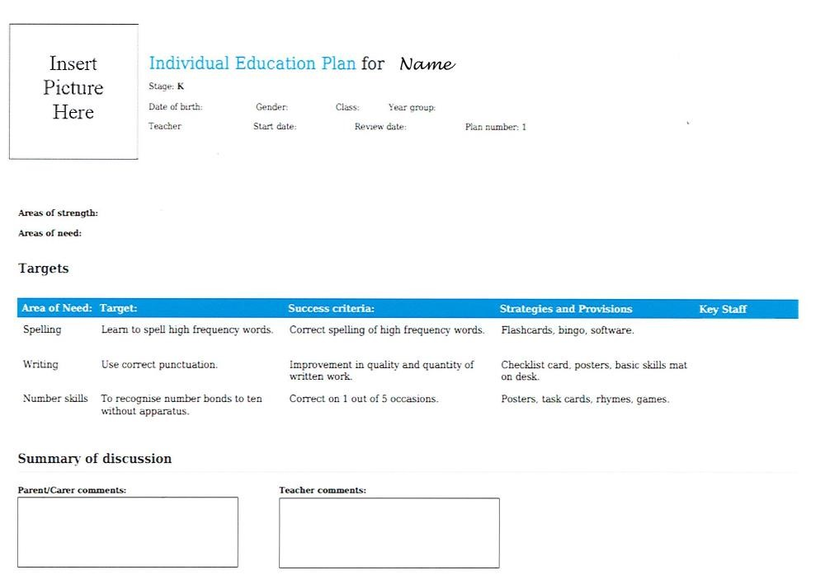

If my child is placed on the school’s SEND register, will they always stay on it?
Some children may need to be on the register for much of their time in school. Others will move off the register when, after careful review of their progress, it has been decided that the child no longer requires special educational provision.

For example, a child might be removed from the school’s SEND register if they have made sufficient progress over a period of time and are able to access the curriculum successfully, without additional support at School Support Level. For some children it is possible that they will dip in and out of additional support throughout their school experience; parents/carers will be consulted at each stage if support is provided or when it will cease. Once removed from the SEND register, a child’s progress will continue to be monitored through the TEACH Trust tracking system to ensure they are making appropriate progress.

When is SEND School Support not enough?
Occasionally, the support provided does not result in enough progress being made, due to ongoing and long-term complex needs and difficulties. Despite high levels of regularly reviewed support and intervention, through the graduated approach, the child/young person`s progress may still be very limited, and this indicates that long term specialist input and/or additional resources may be required to continue access to the full curriculum and to allow participation in school activities. If this is the case, the school (in consultation with parents/carers and external professionals) will consider making a request to the SEND Statutory Services Team at the Local Authority for consideration of an Educational and Health Care Plan (EHCP). Where appropriate, the school and the SEND Statutory Services Team will support parents/carers through the completion of this request.

Statutory: (EHCP)
Only a small percentage of children/young people with SEND will require the support of an Education, Health and Care Plan. When a child/young person’s needs are complex, severe and long term and an education provider cannot meet their needs from within their own resources, and they have exhausted all SEND support options, a statutory assessment of the child/young person’s needs will be considered. With additional support and appropriate funding, we would like to ensure Quality First Teaching, including evidenced, robust use of the ‘assess-plan-do-review cycle’, rigorous teacher oversight, and close liaison between the setting and family continues.

Why might the school seek external advice and support?
On occasion, where additional support in school has been implemented, and progress is still a cause for concern in a graduated response, the school may seek additional advice from, and additional funding for, specialist agencies to help plan the next steps. This may include referrals to the Dorset Speech and Language Therapy Services, Community Paediatrician, Outreach Services, Hearing and Vision Support or Children and Adolescent Mental Health Service (CAMHS). In a few specific circumstances, this may also involve referrals to the Educational Psychology Service, however, this service is at limited capacity and has high thresholds for referrals. Parental permission will always be sought before contacting any external agency for advice.
We work closely with a range of services:
- NHS Dorset Speech and Language Therapy
- Hearing Support Services
- Vision Support Services
- Physiotherapy and Occupational Therapy (Children’s Therapy Team at NHS Poole Hospital)
- Children and Young People’s Social Care
- School Nurse
- GPs and Health Visitors
- Paediatricians (community and hospital based)
- Child and Adolescent Mental Health Service (CAMHS)
- Family Outreach and Attendance Team
- Outreach Support Services (Montacute, Winchelsea and Longspee)
- BCP Educational Psychology Service

Financial support may be needed in order to implement and facilitate some external provision (such as OT and Physio), and on occasion, the school may seek additional funding for those services.

In addition, each school’s Inclusion Leader also acts as a Designated Teacher for looked-after children and previously looked-after children. In line with our Designated Teacher policy, they ensure the specific needs of looked-after and previously looked-after children are understood by all staff. They liaise with the Virtual School Head from the local authority, who provide professional information and advice.

What does SEND provision look like in your Trust?
Children who are on the SEND register will have an Individual Education Plan (IEP) and provision map (Pupil Passport), and each year this information is transferred to the next class teacher, so staff are aware of the needs of pupils in their class. Staff receive ongoing support throughout the year, and will take part in SEND conferencing with the Inclusion Leader; this is an opportunity to have a detailed discussion about the needs and provision of all children with SEND in their class. Staff support may also include training from the Head of Inclusion and SEND, Inclusion Leader, specialist agencies or other professionals with relevant experience. Early Careers Teachers (ECTs) receive additional support and training in meeting the needs of pupils. Staff training and development needs are identified as part of the Trust’s appraisal system and carefully reviewed.

Additionally, our pastoral care team adopt a ‘whole child’ approach, supporting pupils to feel emotionally secure at school. We have a full time Pastoral Care Worker in each school, as well as a trained Emotional Literacy Support Assistant (ELSA) to support pupils with their emotional and social development.

We also work extremely closely with a local special school, and where appropriate, seek advice and support from their experienced staff.

Subject to appropriate levels of resourcing to meet need, we intend to offer the following specialised equipment and facilities for pupils with SEND:
- A well-resourced pastoral room.
- A wide range of speech and language resources.
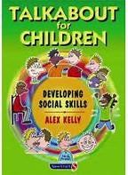

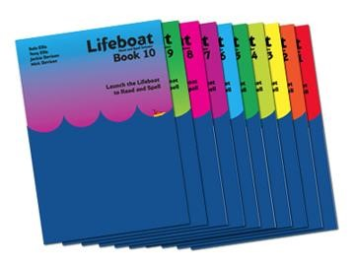
- A wide range of inclusive classroom resources including writing slopes, supportive writing implements, ear defenders, coloured reading rulers, coloured overlays, wobble cushions, sensory and fiddle toys.
- Access to designated sensory or calm spaces.
- A wheelchair accessible site.

Staff are also trained in a range of interventions to support learning and development.

How do you know that the provision is working?
We strive to ensure that all pupils with SEND are happy and thrive in school, and their progress is monitored closely. All of our interventions have assessment measures, which staff can use to baseline children and assess their progress over time. If a child has made measurable progress from their starting point, then staff can calculate the rate of progress (below expected, expected or accelerated). The rate of progress will inform staff of the impact the provision has had on the pupil and whether or not it should continue or if further adaptations need to be made.

As a Trust, we measure children’s attainment and progress in learning against national and age-related expectations. The class teachers, Year Leaders and full Senior Leadership Team will track the progress of individual children. They regularly monitor classroom practice through a variety of methods: work scrutiny, planning scrutiny and classroom observations. The Head of Inclusion and SEND, Head of Curriculum and Standards, Inclusion Leaders and Speech and Language Coordinators will also carry out specific SEND learning environment walks and feedback findings to staff in order to inform next step planning and provision. As well as this, all interventions are tracked robustly each half term and where necessary adaptations are made. The Trust board also tracks pupils’ progress and monitors teaching and learning standards regularly.

Provision is also reviewed as part of the Individual Education Plan (IEP) and graduated response cycle. Children on the SEND register will have an Individual Education Plan (IEP) with personalised short-term targets, which are reviewed by the class teacher termly, alongside the pupil and in partnership with parents/carers, so that the best possible outcomes are planned effectively. As part of this process, targets, strategies and provision are carefully evaluated and new targets set in relation to the child’s individual progress. If a child does not make expected progress with a target, then either the target will be adjusted or the support and provision will be amended, as appropriate.



How will you prepare for my child with an additional need to join your school?
Pre-school to EYFS transfer
All new children starting EYFS will be invited to visit the school prior to starting. The transition is carefully planned to allow for a gradual and smooth transition. Some children may require several visits to become familiar with their new surroundings. Photo passports will be created for all children to further support this process.

For children in pre-schools who are already identified with SEND, a meeting is arranged between the nursery setting SENDCo, parents and school staff to ensure that key information is shared. Parents are able to explore any concerns or questions they may have. At this meeting, any additional support will be discussed, as we would like to plan for appropriate provision and early intervention where possible.

Key Stage 1 to Key stage 2 transfer
Many pupils will transfer from our TEACH Trust infant schools to our junior schools (often Ad Astra to Haymoor Junior and Canford Heath Infant to Canford Heath Junior). The Inclusion Leaders intend to oversee all plans regarding transition, with transition plans undertaken in the summer term to ensure that pupils with SEND are prepared for the transfer.

Year 2 and Year 3 staff and both pastoral teams work closely together to ensure that the transfer is as smooth as possible. The close working relationship between the Inclusion Leaders across the Trust means that parents of pupils identified with SEND should feel reassured to know that there is a consistent approach for them and the transfer of information and support for these pupils should be successful.

Where children transfer to junior school from other feeder infant schools, the Inclusion Leader will aim to liaise with the SENDCo/ Inclusion Leader and pastoral staff of the feeder school to ensure that the needs of the pupils can be met and that all information has been shared with staff. A meeting can be arranged with parents to explore any concerns or questions they may have. At this meeting, any additional support will be discussed, as we would like to plan for appropriate provision where possible.

In-year transfer
For pupils joining us in year from other schools, an initial meeting with parents will be offered to discuss any needs and concerns. If your child has specific needs, please ask to see the Inclusion Leader prior to start date to ensure we are fully prepared for your child’s first day. In addition, the Inclusion Leader will contact the feeder school to ensure that all relevant information is transferred.

What happens when my child leaves your school?
Children leaving our setting
We will liaise with receiving schools for all ‘leavers’, ensuring that all key information is shared once your child is on roll.

Moving from KS2 to Secondary
For cohorts of children leaving the school at the end of the key stage, we identify any vulnerable pupils and arrange for additional visits where necessary. The secondary school’s SENDCo/Inclusion Leader, pastoral care worker and Year Six staff work together to lead a programme to support transition during the summer term.

Transfer planning meetings can be arranged with the SENDCo/Inclusion Leader at the receiving school. If a pupil has complex needs and an Education, Health and Care Plan (EHCP), a transition meeting with parents and staff from both schools will be arranged – this meeting may also be the pupil’s annual review of their EHCP. The pastoral team and Inclusion Leader ensure that all relevant paperwork is confidentially passed on and all pupil needs are discussed and understood.

How do I make a complaint?
If you want to complain about a school’s SEND support, you should do it while your child is still registered at the school. This includes complaints that the school has not provided the support required by your child’s Educational, Health and Care plan (EHCP).

It is in everyone’s interests for concerns /complaints to be resolved as quickly as possible. Complaints about SEND provision in our schools should be made by following these steps in order. Please move on to the next step if your complaint is not resolved.

- Talk to the class teacher - The class teacher deals with the complaint initially and the complainant needs to feel they have been listened to and that all the points raised have been addressed. If there is no further resolution, the complaint is then dealt with by the Inclusion Leader.
- Talk to the school’s Inclusion Leader - If at this stage, there is still no resolution, then the complainant should use the school’s complaints policy.
- Follow the school’s complaints procedure as per the school’s complaints policy. The TEACH Trust complaints procedure is available on each school’s website and can be requested via the school office
- Complain to the ESFA

Who completed this form?
Miss N. Brown
Head of Inclusion and SEND
TEACH Trust
Canford Heath Junior School – 01202 676393 – office@chjs.poole.sch.uk

Mrs S. Chandler
Inclusion Lead
Ad Astra Infant School - 01202 602113 - office@adastra.poole.sch.uk

Mrs J. Hardwicke
Inclusion Lead
Canford Heath Infant School – 01202 380015 - office@chis.poole.sch.uk

Mr S Proffitt
Deputy Head Teacher and Inclusion Lead
Haymoor Junior School - 01202 659290 - office@hjs.poole.sch.uk

Mrs S. Turner
Inclusion Lead
Canford Heath Junior School – 01202 676393 – office@chjs.poole.sch.uk

Last reviewed: September 2025
Review Due: September 2026

Appendix 1: TEACH Trust SEND data and contact list

 | Ad Astra Infant School | Haymoor Junior School | Canford Heath Infant School | Canford Heath Junior School
% Of children with  SEND from  September 2025 (mainstream only) | 22% | 27% | 15% | 18%
% Of children with  SEND from  September 2025 (including SRP) | - | - | 18% | 22%
SLCN Resource Base Managers | - | - | Miss White | Mrs Ruddock
Inclusion Lead | Mrs Chandler | Mr Proffitt | Mrs Hardwicke | Mrs Turner
Speech and  Language Coordinator | Mrs Mannering | Mrs Mannering | Mrs Baker | Mrs Baker
Pastoral Care Worker | Mrs Penfold | Mrs Killahena | Mrs Lippitt | Miss Cobb
Emotional Literacy Support Assistant (ELSA) | Tania Howells | Mrs Wilson | Mrs Tout | Mrs Fleming
Home Academy  Liaison Officer  (HALO) | Mrs Specterman | Mrs Specterman | Mrs Specterman | Mrs Specterman
Attendance and Welfare Officer (AWO) | Mrs Bates | Mrs Bates | Mrs Bates | Mrs Bates
Medical  Administration Officer | Mrs Cox | Rebecca Smith | Mrs Denton | Mrs Falleson

Appendix 2: Acronyms Glossary
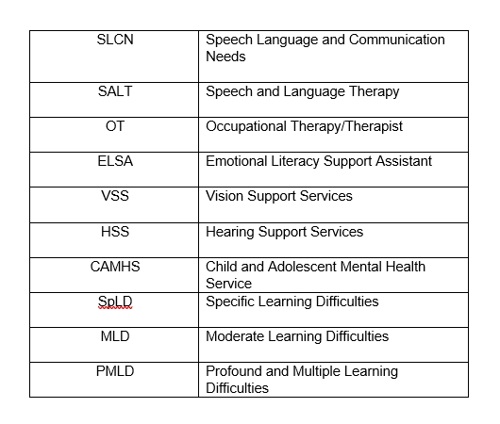
SEND | Special Educational Needs and /or Disabilities
EHCP or EHC Plan | Education, Health and Care Plan
C&I | Communication and Interaction
C&L | Cognition and Learning
PD | Physical Disability
VI | Visual Impairment
HI | Hearing Impairment
SEMH | Social Emotional and Mental Health
ADHD | Attention Deficit and Hyperactivity Disorder
ADD | Attention Deficit Disorder
ASC/ASD | Autistic Spectrum Condition /Autistic Spectrum Disorder

