
Canford Heath Junior School

Child Protection & Safeguarding 2026-2027
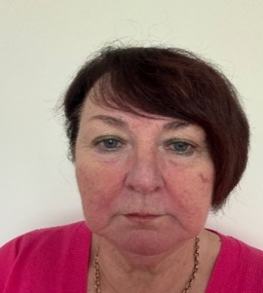
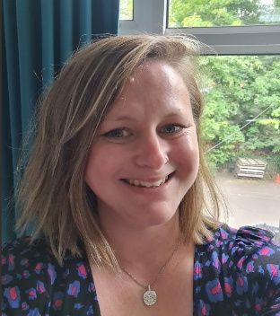


Designated Safeguarding Lead:
Amy Williams

Designated Safeguarding Trustee:
Julie Jeans
Designated Deputy Safeguarding Lead:
Mark Wilson
Designated Deputy
Safeguarding Lead:
Kate Carter

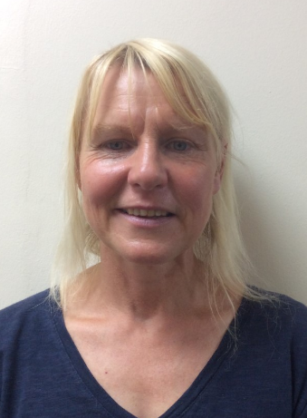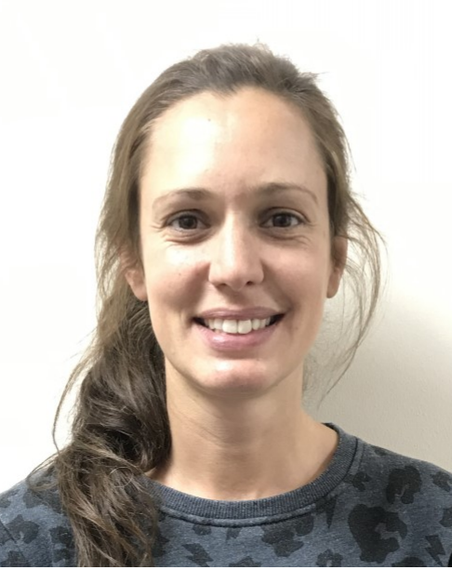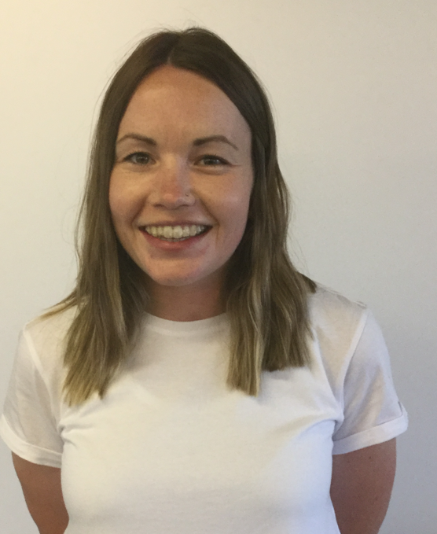
Designated
Anti-bullying Champion:
Rowan Young
Designated
E-Safety Champion:
Chloe Tizzard
Home Academy Liaison Officer:
Lesley Specterman
Designated Deputy Safeguarding Lead:
Rachel Cobb

￼

Prevent Lead: Amy Williams
Site Security Lead: Simon Caveney
BCP Local Authority Designated Officer (LADO)
Allyson Donovan, Hayley Cowmeadow, Tina Cooper
Telephone: 01202 817 600
Email: LADO@bcpcouncil.gov.uk

